Course Code | CSE4004 | Class ID | AP2025264000563
Course Title | Web Technologies Lab | Slot | L20+L21
Faculty Name | Dr.MD.Sirajuddin


Name: | Shanmukesh Bonala
Reg No. | 23BCE20070

LIST OF EXPERIMENTS
- Design a Portfolio webpage consisting of the following
- Student Name
- Profile Pic
- Career Objective
- Short Introduction
- Educational Qualifications
- Technical Skills
- Project Details
- Internship/Certifications
- Hobbies
- Achievements
- Contact Information (email, link to social media pages)
<!DOCTYPE html>
<html lang="en">
<head>
<title>Student Portfolio</title>
</head>
<body>
<!-- Header Section -->
<header>
<h1>Student Portfolio</h1>
<center>
<h1>SHANMUKESH BONALA</h1>
<figure>
<img src="images/image.png" alt="Profile Picture" title="Profile Picture" height="200px">
<figcaption>Shanmukesh</figcaption>
</figure>
</center>
<h3>Career Objective</h3>
<p>I am a passionate and dedicated student pursuing a Bachelor's degree in Computer Science. My goal is to leverage my technical skills and creativity to contribute to innovative projects and drive impactful solutions in the field of technology.</p>

<h3>Short Introduction</h3>
<p>Hello! I'm John Doe, a final-year B.Tech student specializing in Computer Science and Engineering. I enjoy solving complex problems, exploring new technologies, and working on projects that make a difference. My interests lie in artificial intelligence, web development, and data science.</p>
</header>

<!-- Main Content -->
<main>
<!-- Educational Qualifications -->
<section>
<h2>Educational Qualifications</h2>
<table border="1">
<tr>
<th>Degree</th>
<th>Institution</th>
<th>Year</th>
<th>CGPA/Percentage</th>
</tr>
<tr>
<td>B.Tech in Computer Science</td>
<td>VIT-AP University</td>
<td>2023 - 2027</td>
<td>9.26 CGPA</td>
</tr>
<tr>
<td>Intermediate (12th)</td>
<td>Bheeram Sridhar Reddy Junior college</td>
<td>2023</td>
<td>97.3%</td>
</tr>
<tr>
<td> (10th)</td>
<td>Sri Chaitanya School</td>
<td>2021</td>
<td>100%</td>
</tr>
</table>
</section>

<!-- Technical Skills -->
<section>
<h2>Technical Skills</h2>
<ol type="I">
<li>Programming Languages: Python, Java, C++</li>
<li>Web Development: HTML, JavaScript (Basic)</li>
<li>Databases: MySQL, MongoDB</li>
<li>Tools: Git, VS Code, Jupyter Notebook</li>
<li>Other Skills: Machine Learning, Data Analysis</li>
</ol>
</section>

<!-- Project Details -->
<section>
<h2>Project Details</h2>
<ul>
<li><strong>Project 1:</strong> Weather Forecasting App (Python, Flask)</li>
<li><strong>Project 2:</strong> E-Commerce Website (HTML, CSS, JavaScript)</li>
<li><strong>Project 3:</strong> Chatbot for Customer Support (Python, NLP)</li>
</ul>
</section>

<!-- Internship/Certifications -->
<section>
<h2>Internship/Certifications</h2>
<dl>
<dt>Internship at Tech Solutions Pvt. Ltd</dt>
<dt>Certification in Machine Learning</dt>
</dl>
</section>

<!-- Hobbies -->
<section>
<h2>Hobbies</h2>
<ul>
<li>Reading books</li>
<li>Playing chess</li>
<li>Coding</li>
<li>Photography</li>
</ul>
</section>

<!-- Achievements -->
<section>
<h2>Achievements</h2>
<ul>
<li>1st Prize in National Level Coding Competition</li>
<li>Published a research paper on "AI in Healthcare"</li>
<li>Volunteered for community service projects</li>
</ul>
</section>
</main>

<!-- Footer with Contact Information -->
<footer>
<h2>Contact Information</h2>
<p>Email: <a href="mailto:john.doe@example.com">shanmukesh.bonala@gmail.com</a></p>
<p>LinkedIn: <a href="https://linkedin.com/in/johndoe" target="_blank">LinkedIn Profile</a></p>
<p>GitHub: <a href="https://github.com/johndoe" target="_blank">GitHub Profile</a></p>
<p>Location: Ananthapur, Andhra Pradesh, India</p>
</footer>
</body>
</html>
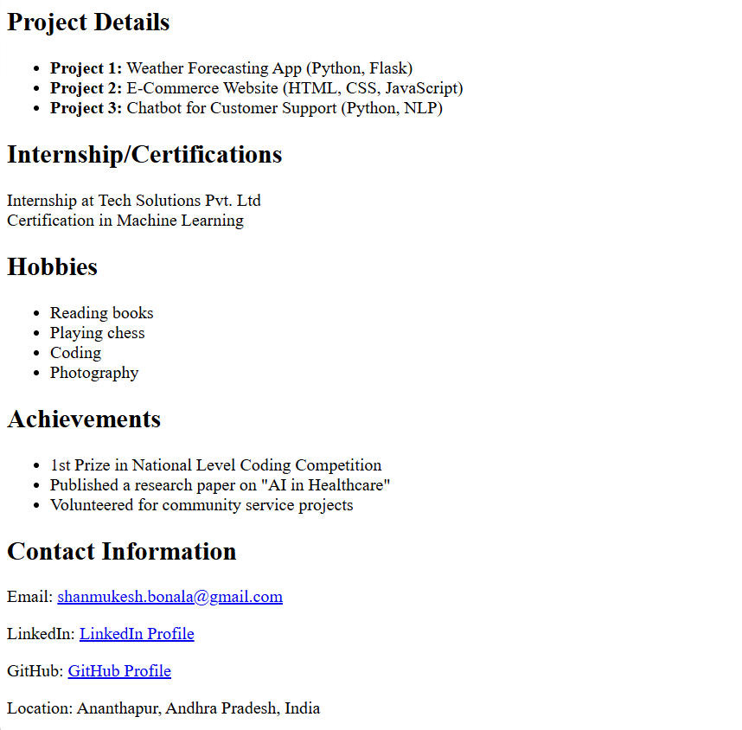
- Design a Student Registration Form
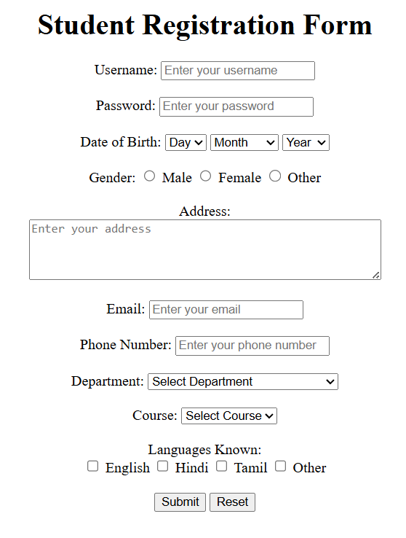
<!DOCTYPE html>
<html lang="en">
<head>
<title>Student Registration Form</title>
</head>
<body>
<center>
<h1>Student Registration Form</h1>
<form>
<!-- Username -->
<label for="username">Username:</label>
<input type="text" id="username" name="username" placeholder="Enter your username" required><br><br>

<!-- Password -->
<label for="password">Password:</label>
<input type="password" id="password" name="password" placeholder="Enter your password" required><br><br>

<!-- Date of Birth -->
<label>Date of Birth:</label>
<select id="day" name="day" required>
<option value="">Day</option>
<option value="1">1</option>
<option value="2">2</option>
<option value="3">3</option>
<!-- Add more days -->
</select>
<select id="month" name="month" required>
<option value="">Month</option>
<option value="January">January</option>
<option value="February">February</option>
<option value="March">March</option>
<!-- Add more months -->
</select>
<select id="year" name="year" required>
<option value="">Year</option>
<option value="2000">2000</option>
<option value="2001">2001</option>
<option value="2002">2002</option>
<!-- Add more years -->
</select><br><br>

<!-- Gender -->
<label>Gender:</label>
<input type="radio" id="male" name="gender" value="male" required>
<label for="male">Male</label>
<input type="radio" id="female" name="gender" value="female">
<label for="female">Female</label>
<input type="radio" id="other" name="gender" value="other">
<label for="other">Other</label><br><br>

<!-- Address -->
<label for="address">Address:</label><br>
<textarea id="address" name="address" rows="4" cols="50" placeholder="Enter your address" required></textarea><br><br>

<!-- Email -->
<label for="email">Email:</label>
<input type="email" id="email" name="email" placeholder="Enter your email" required><br><br>

<!-- Phone Number -->
<label for="phone">Phone Number:</label>
<input type="tel" id="phone" name="phone" placeholder="Enter your phone number" required><br><br>

<!-- Department -->
<label for="department">Department:</label>
<select id="department" name="department" required>
<option value="">Select Department</option>
<option value="CSE">Computer Science</option>
<option value="ECE">Electronics and Communication</option>
<option value="ME">Mechanical Engineering</option>
<option value="CE">Civil Engineering</option>
</select><br><br>

<!-- Course -->
<label for="course">Course:</label>
<select id="course" name="course" required>
<option value="">Select Course</option>
<option value="B.Tech">B.Tech</option>
<option value="M.Tech">M.Tech</option>
<option value="PhD">PhD</option>
</select><br><br>

<!-- Languages Known -->
<label>Languages Known:</label><br>
<input type="checkbox" id="english" name="languages" value="english">
<label for="english">English</label>
<input type="checkbox" id="hindi" name="languages" value="hindi">
<label for="hindi">Hindi</label>
<input type="checkbox" id="tamil" name="languages" value="tamil">
<label for="tamil">Tamil</label>
<input type="checkbox" id="other_lang" name="languages" value="other">
<label for="other_lang">Other</label><br><br>

<!-- Submit and Reset Buttons -->
<input type="submit" value="Submit">
<input type="reset" value="Reset">
</form>
</center>
</body>
</html>

- Create the following patterns using HTML and CSS only.
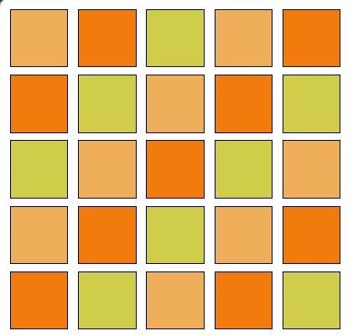
<!DOCTYPE HTML>
<html>
<head>
<style>
.container{
color:red;
/* background-color: brown; */
display: grid;
/* border: 1px solid black; */
padding: 2px;

/* margin: auto; */
grid-template-columns: repeat(5, 60px);
grid-auto-flow: row;
grid-gap: 5px;
}
.child{
background-color: aqua;
text-align: center;
justify-content: center;
height: 50px;
width: 50px;
padding: 2px;
margin: 1px;
border: 1px solid black;
}
.brown1{
background-color: rgb(238, 174, 90);
}
.brown2{
background-color: rgb(241, 123, 12);
}
.brown3{
background-color: rgb(207, 205, 74);
}
</style>
</head>
<body>
<div class="container">
<div class="child brown1"></div>
<div class="child brown2"></div>
<div class="child brown3"></div>
<div class="child brown1"></div>
<div class="child brown2"></div>

<div class="child brown2"></div>
<div class="child brown3"></div>
<div class="child brown1"></div>
<div class="child brown2"></div>
<div class="child brown3"></div>

<div class="child brown3"></div>
<div class="child brown1"></div>
<div class="child brown2"></div>
<div class="child brown3"></div>
<div class="child brown1"></div>

<div class="child brown1"></div>
<div class="child brown2"></div>
<div class="child brown3"></div>
<div class="child brown1"></div>
<div class="child brown2"></div>

<div class="child brown2"></div>
<div class="child brown3"></div>
<div class="child brown1"></div>
<div class="child brown2"></div>
<div class="child brown3"></div>
</div>
</body>
</html>

- Implement Drag n Drop feature in HTML 5
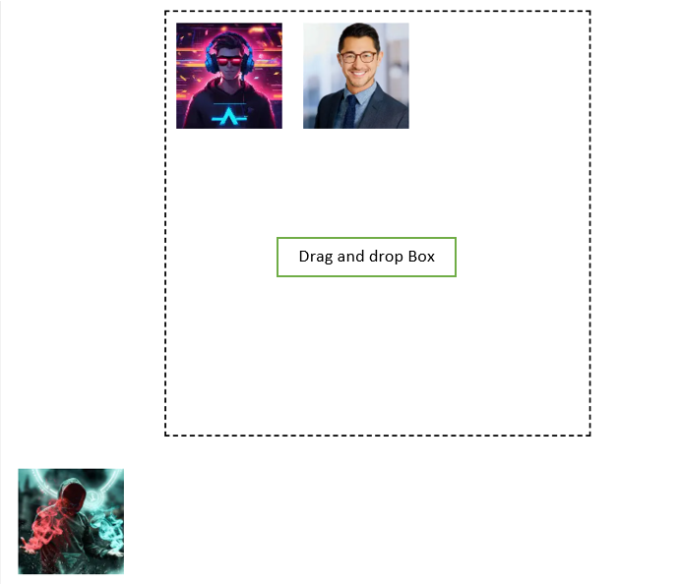
<!DOCTYPE html>
<html lang="en">
<head>
<title>Drag and Drop Demo</title>
<style>
/* Minimal styling for clarity (optional) */
#dropBox {
width: 400px;
height: 400px;
border: 2px dashed black;
margin: 20px auto;
}
.draggable {
height: 100px;
width: 100px;
margin: 10px;
cursor: move;
}
</style>
</head>
<body>
<div id="dropBox" ondragover="dragOver(event)" ondrop="drop(event)"></div>

<div>
<img src="images/image1.png" class="draggable" id="image1" draggable="true" ondragstart="dragStart(event)">
<img src="images/image2.png" class="draggable" id="image2" draggable="true" ondragstart="dragStart(event)">
<img src="images/image.png" class="draggable" id="image3" draggable="true" ondragstart="dragStart(event)">
</div>

<script>
// Allow drop by preventing default
function dragOver(event) {
event.preventDefault();
}

// Handle drop
function drop(event) {
event.preventDefault();
const data = event.dataTransfer.getData("text");
const draggedElement = document.getElementById(data);
event.target.appendChild(draggedElement);
}

// Set data on drag start
function dragStart(event) {
event.dataTransfer.setData("text", event.target.id);
}
</script>
</body>
</html>

- Design a Calculator using Java script and relevant CSS.
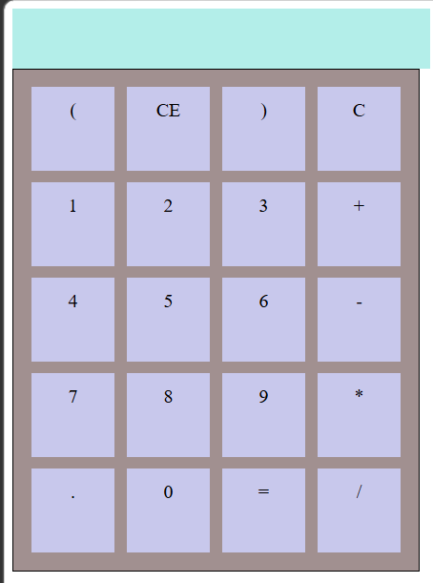
<!DOCTYPE>
<html>
<head>

<style>
.outerBox{
display: grid;
border: 1px solid black;
padding: 10px;
background-color: rgb(161, 144, 144);
width: 320px;
}
.row{
display: flex;
}
.ele{
display: flex;
height: 50px;
width: 50px;
background-color: rgb(200, 200, 236);
margin: 5px;
justify-content: center;
text-align: center;
padding: 10px;
}
.display{
width: 350px;
height: 50px;
background-color: rgb(179, 238, 233);
}

</style>
</head>
<body>
<div class="display" id="display">

</div>
<div class="outerBox">
<div class="row">
<div class="ele" id="_1">(</div>
<div class="ele" id="_2">CE</div>
<div class="ele" id="_3">)</div>
<div class="ele" id="_4">C</div>
</div>
<div class="row">
<div class="ele" id="_5">1</div>
<div class="ele" id="_6">2</div>
<div class="ele" id="_7">3</div>
<div class="ele" id="_8">+</div>
</div>
<div class="row">
<div class="ele" id="_9">4</div>
<div class="ele" id="_10">5</div>
<div class="ele" id="_11">6</div>
<div class="ele" id="_12">-</div>
</div>
<div class="row">
<div class="ele" id="_13">7</div>
<div class="ele" id="_14">8</div>
<div class="ele" id="_15">9</div>
<div class="ele" id="_16">*</div>
</div>
<div class="row">
<div class="ele" id="_17">.</div>
<div class="ele" id="_18">0</div>
<div class="ele" id="_19">=</div>
<div class="ele" id="_20">/</div>
</div>
</div>
</body>
<script>
const display = document.getElementById("display");
const buttons = document.querySelectorAll(".ele");

buttons.forEach(button => {
button.addEventListener( "click",() =>{
const value = button.textContent;
// display.textContent = value;
console.log(value);
if(value=="C"){
display.textContent = "";
}else if(value=="="){
display.textContent = eval(display.textContent);
}else{
display.textContent += value;
}
})
})
</script>
</html>

- Design an Income Tax Calculator using Java script and CSS.
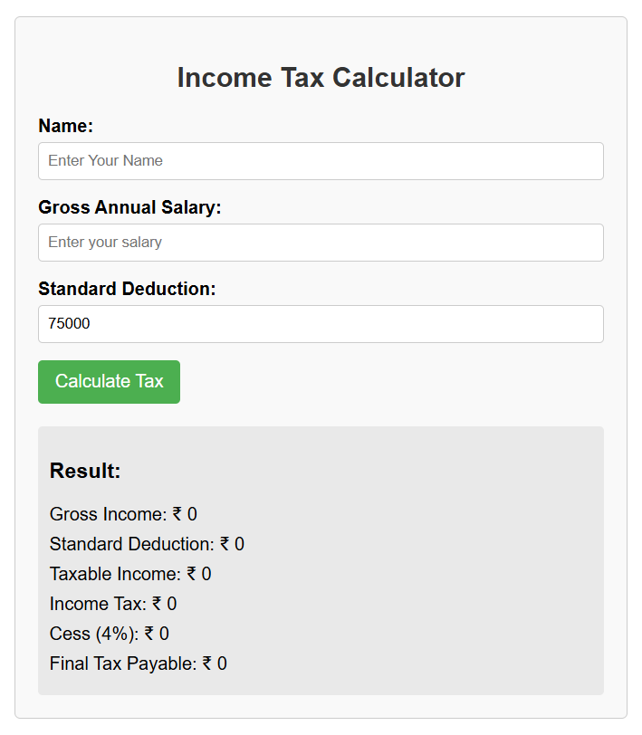
<!DOCTYPE html>
<html lang="en">
<head>
<title>Income Tax Calculator</title>
<style>
body {
font-family: Arial, sans-serif;
margin: 20px;
}
.container {
width: 500px;
margin: 0 auto;
border: 1px solid #ccc;
padding: 20px;
border-radius: 5px;
background-color: #f9f9f9;
}
h2 {
color: #333;
text-align: center;
}
.form-group {
margin-bottom: 15px;
}
label {
display: block;
margin-bottom: 5px;
font-weight: bold;
}
input[type="text"], input[type="number"] {
width: 100%;
padding: 8px;
border: 1px solid #ccc;
border-radius: 4px;
box-sizing: border-box;
}
button {
background-color: #4CAF50;
color: white;
padding: 10px 15px;
border: none;
border-radius: 4px;
cursor: pointer;
font-size: 16px;
}
button:hover {
background-color: #45a049;
}
.result {
margin-top: 20px;
padding: 10px;
background-color: #e9e9e9;
border-radius: 4px;
}
.result-item {
margin-bottom: 8px;
}
</style>
</head>
<body>
<div class="container">
<h2>Income Tax Calculator</h2>

<div class="form-group">
<label for="name">Name:</label>
<input type="text" id="name" placeholder="Enter Your Name">
</div>

<div class="form-group">
<label for="salary">Gross Annual Salary:</label>
<input type="number" id="salary" placeholder="Enter your salary">
</div>

<div class="form-group">
<label for="deduction">Standard Deduction:</label>
<input type="number" id="deduction" value="75000" placeholder="Enter deduction">
</div>

<button onclick="calculateTax()">Calculate Tax</button>

<div class="result" id="result">
<h3>Result:</h3>
<div class="result-item">Gross Income: ₹ <span id="grossIncome">0</span></div>
<div class="result-item">Standard Deduction: ₹ <span id="standardDeduction">0</span></div>
<div class="result-item">Taxable Income: ₹ <span id="taxableIncome">0</span></div>
<div class="result-item">Income Tax: ₹ <span id="incomeTax">0</span></div>
<div class="result-item">Cess (4%): ₹ <span id="cess">0</span></div>
<div class="result-item">Final Tax Payable: ₹ <span id="finalTax">0</span></div>
</div>
</div>

<script>
function calculateTax() {
// Get input values
const name = document.getElementById('name').value;
const grossIncome = parseFloat(document.getElementById('salary').value) || 0;
const standardDeduction = parseFloat(document.getElementById('deduction').value) || 0;

// Calculate taxable income
const taxableIncome = grossIncome - standardDeduction;
document.getElementById('grossIncome').textContent = grossIncome.toFixed(2);
document.getElementById('standardDeduction').textContent = standardDeduction.toFixed(2);
document.getElementById('taxableIncome').textContent = taxableIncome.toFixed(2);

// Calculate income tax based on slabs
let incomeTax = 0;
if (taxableIncome <= 400000) {
incomeTax = 0;
} else if (taxableIncome <= 800000) {
incomeTax = (taxableIncome - 400000) * 0.05;
} else if (taxableIncome <= 1200000) {
incomeTax = 20000 + (taxableIncome - 800000) * 0.10;
} else if (taxableIncome <= 1600000) {
incomeTax = 60000 + (taxableIncome - 1200000) * 0.15;
} else if (taxableIncome <= 2000000) {
incomeTax = 120000 + (taxableIncome - 1600000) * 0.20;
} else if (taxableIncome <= 2400000) {
incomeTax = 200000 + (taxableIncome - 2000000) * 0.25;
} else {
incomeTax = 300000 + (taxableIncome - 2400000) * 0.30;
}

// Calculate cess (4%)
const cess = incomeTax * 0.04;

// Calculate final tax
const finalTax = incomeTax + cess;

// Display results
document.getElementById('incomeTax').textContent = incomeTax.toFixed(2);
document.getElementById('cess').textContent = cess.toFixed(2);
document.getElementById('finalTax').textContent = finalTax.toFixed(2);
}
</script>
</body>
</html>

7. Demonstrate CRUD operations using MongoDB
Suppose you are managing a university database. There is a collection called
students with documents containing rollNumber, name, age and cgpa.
i. Create Database University_DB
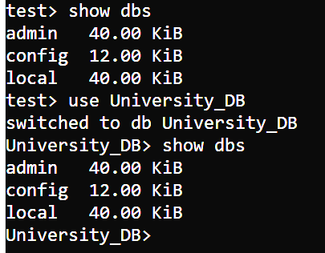
ii. Create Collection Students
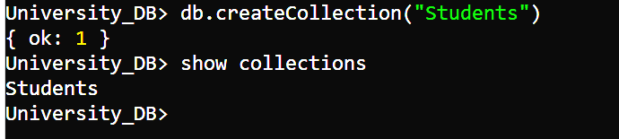
iii. Insert Documents
{ rollNumber: 1, name: &quot;Alice&quot;, age: 20, cgpa: 8.5 }
{ rollNumber: 2, name: &quot;Bob&quot;, age: 21, cgpa: 7.8 }
{ rollNumber: 3, name: &quot;Charlie&quot;, age: 19, cgpa: 9.0 }
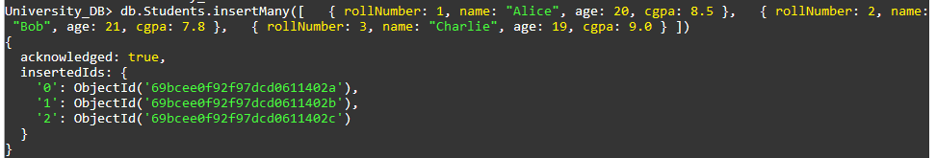
iv. Write a query to insert a new student named &quot;David&quot; with roll number 4, age
22, and CGPA 8.2.
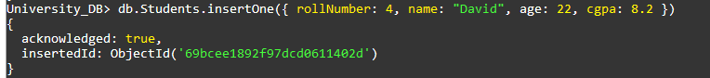
v. Write a query to insert multiple students at once:
• Eve, roll number 5, age 20, CGPA 7.9
• Frank, roll number 6, age 23, CGPA 8.0
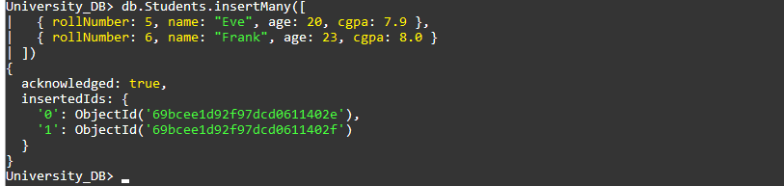
vi. Write a query to find all students in the collection.
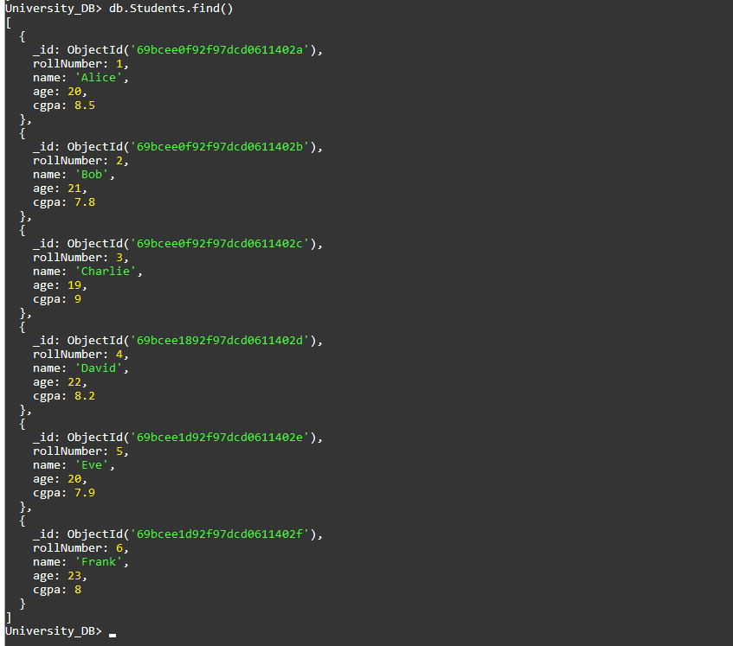
vii. Write a query to find the student named &quot;Alice&quot;.
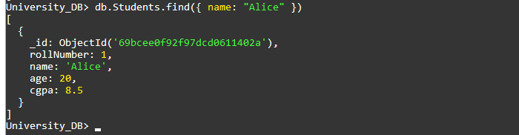
viii. Write a query to find all students older than 20.
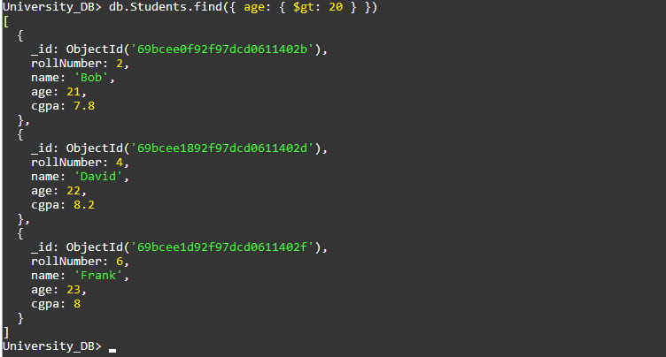
ix. Write a query to find students with CGPA greater than 8.0.
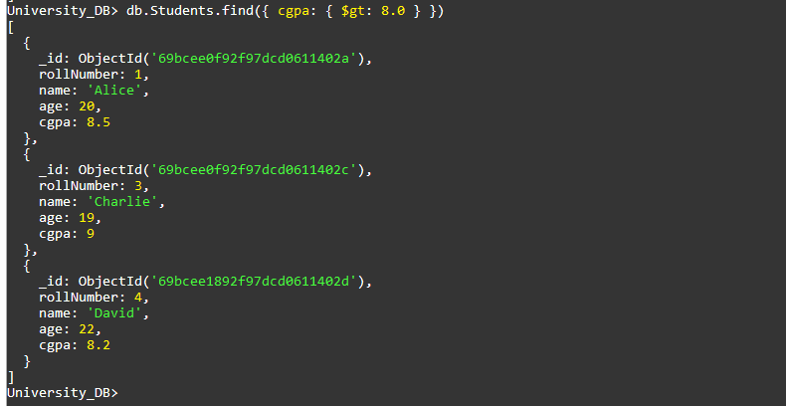

x. Write a query to find students with CGPA between 7.5 and 9.0.
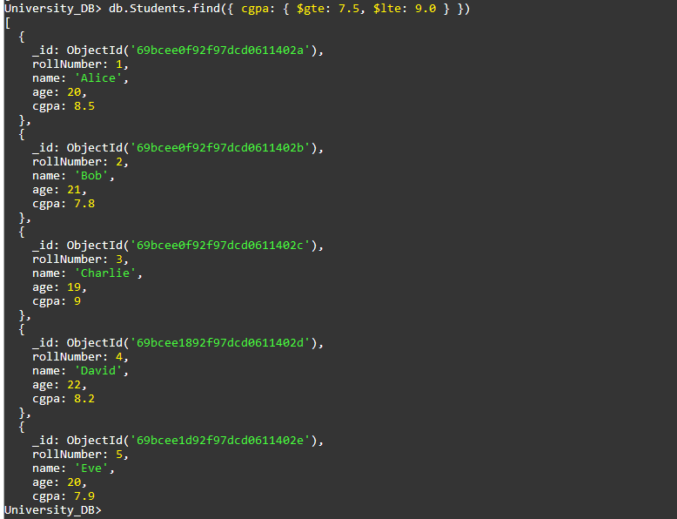
xi. Write a query to update Alice’s CGPA to 8.7.
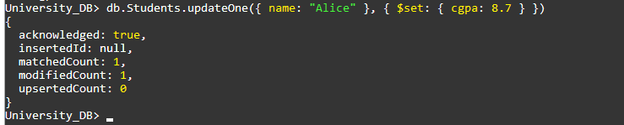
xii. Write a query to increase the CGPA by 0.2 for all students with CGPA less than
8.0.
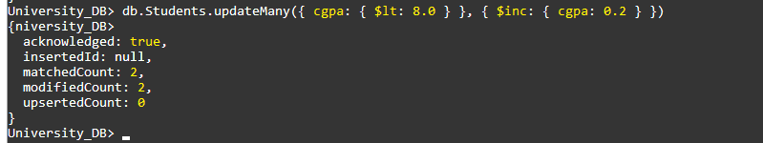
xiii. Write a query to delete the student named &quot;Bob&quot;.

xiv. Write a query to delete all students with CGPA less than 7.5.
8. Download a zip code dataset at http://media.mongodb.org/zips.json. Use mongo
import to import the zip code dataset into Mongo DB. After importing the data,
answer the following questions by using aggregation pipelines:
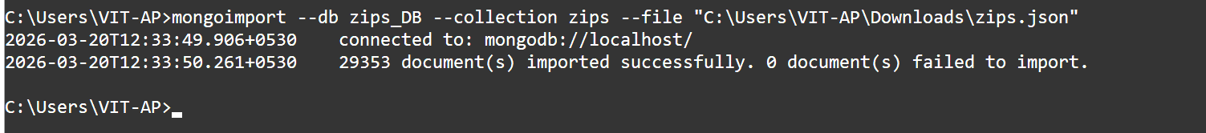
(i) Find all the states that have a city called “BOSTON”.
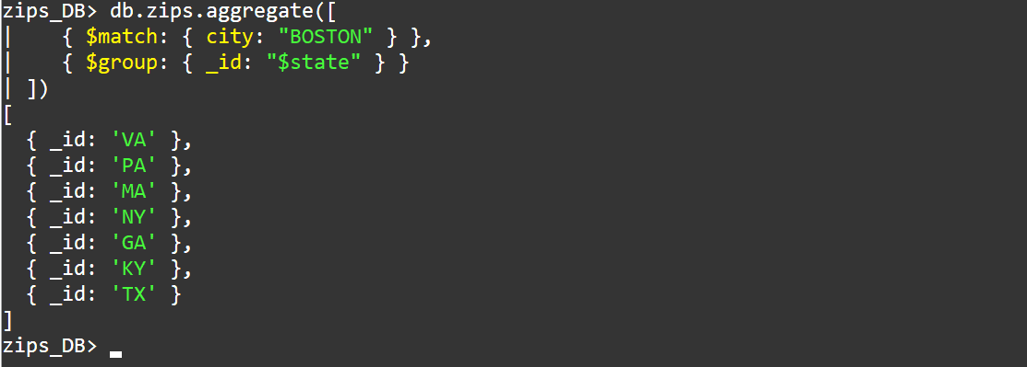
(ii) Find all the states and cities whose names include the string “BOST”.
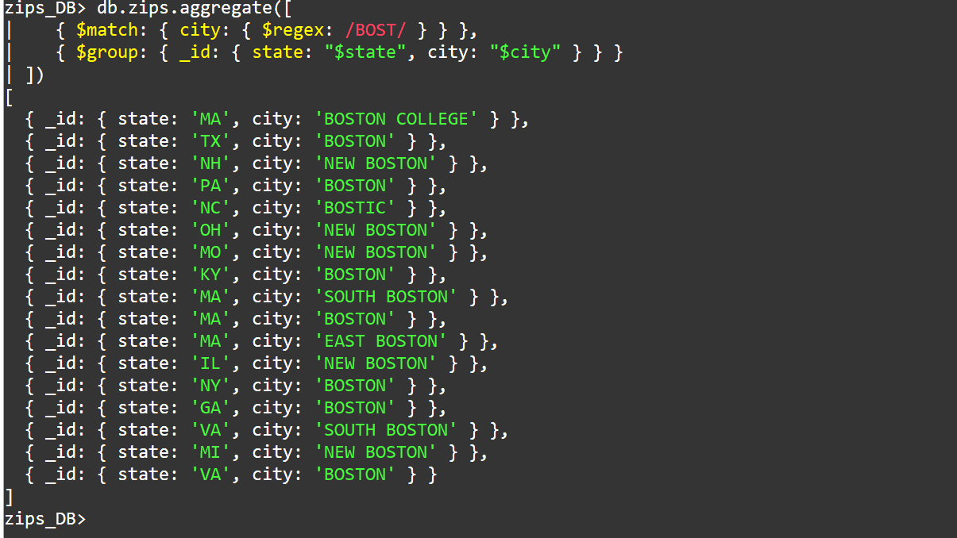

(iii) Count zip codes and population for each city in each state.
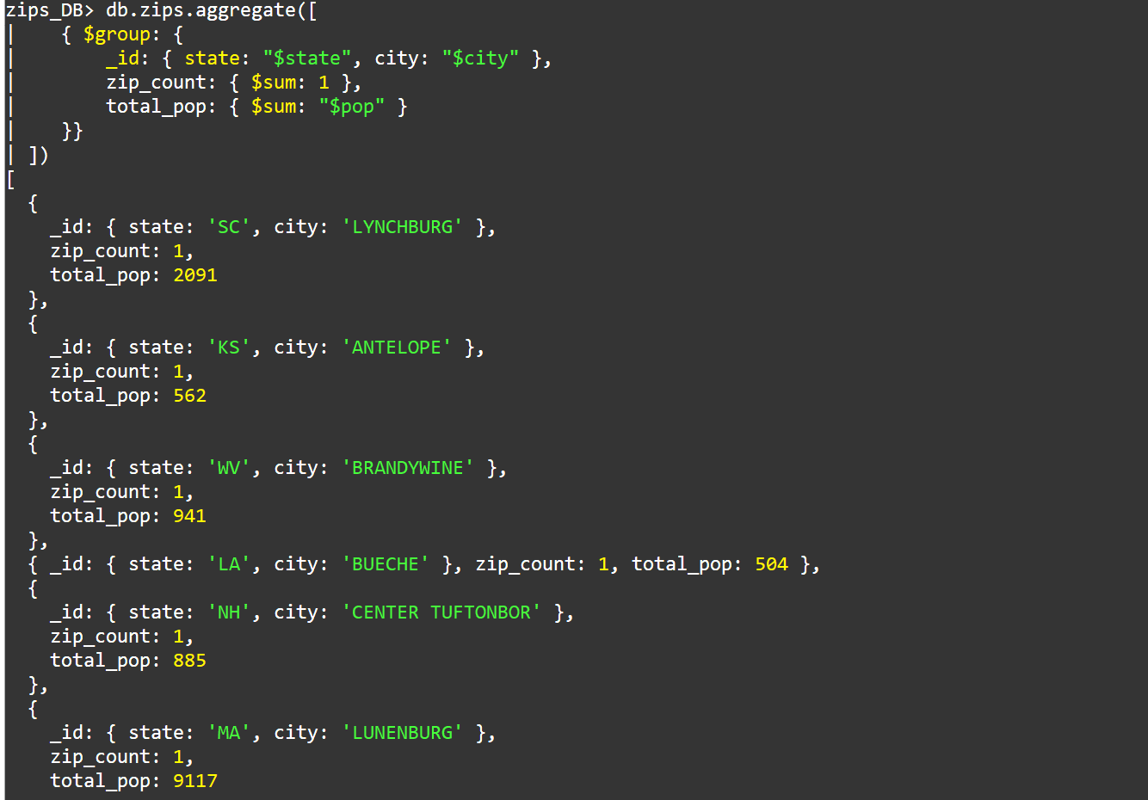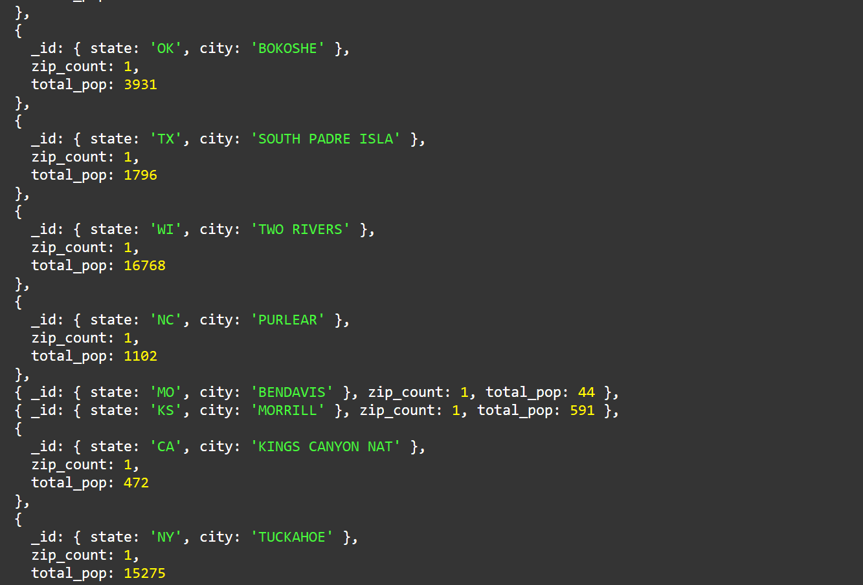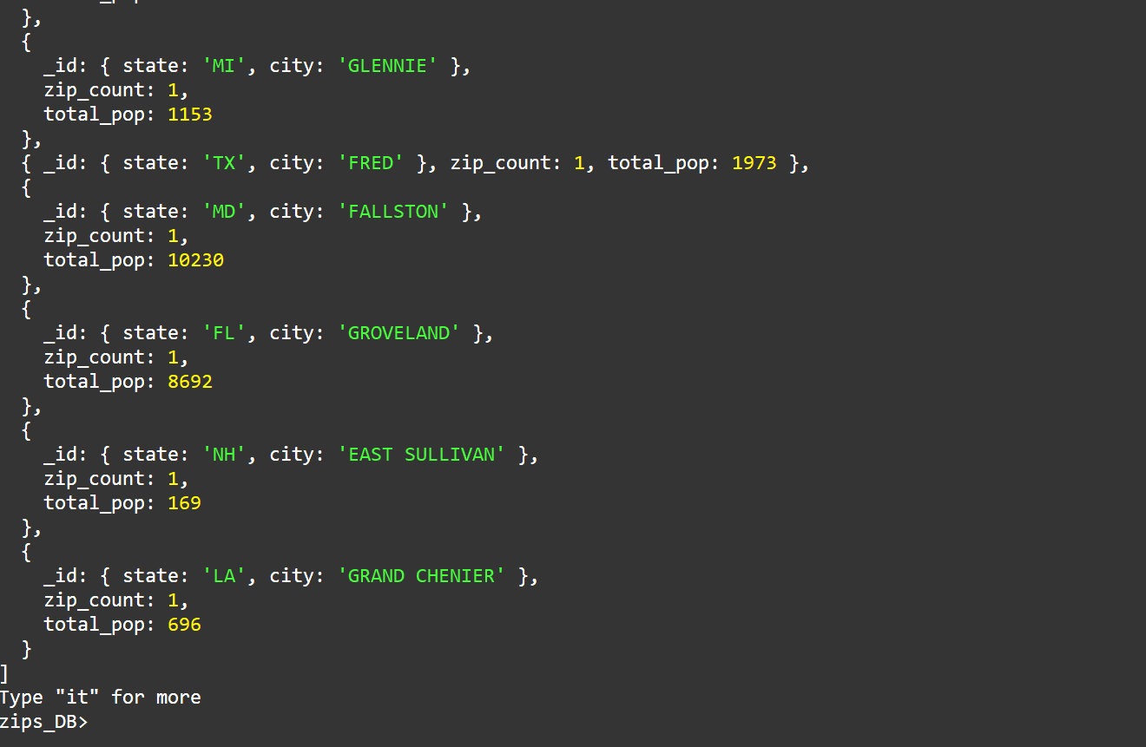
(iv) Find the city with the maximum zip codes in each state and rank by population.
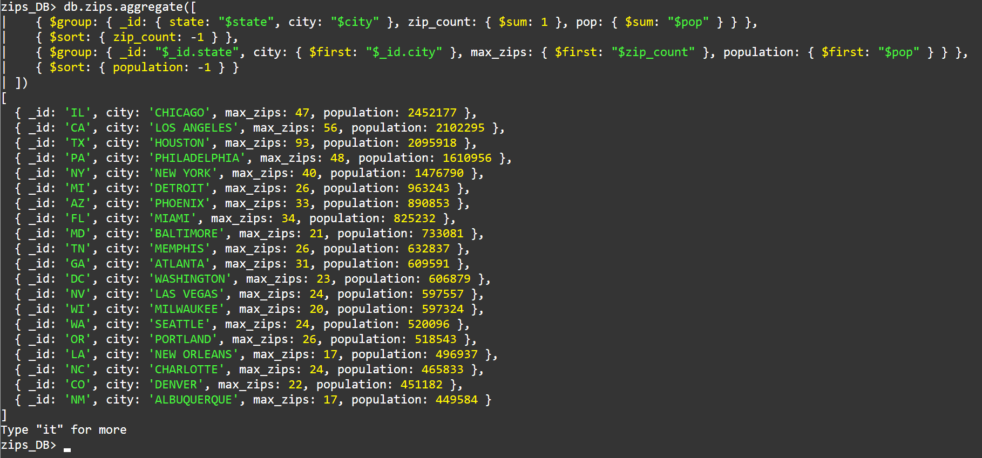

9. Implement a JavaScript program that reads data from a JSON file using AJAX and displays the retrieved information dynamically on a webpage.
<!DOCTYPE html>
<html lang="en">
<head>
<meta charset="UTF-8">
<meta http-equiv="X-UA-Compatible" content="IE=edge">
<meta name="viewport" content="width=device-width, initial-scale=1.0">
<title>AJAX</title>

</head>
<body>
<div id="demo">
<h2>AJAX</h2>
<button type="button" onclick="loadDoc()">Change Content</button>
</div>
<div id="demo2">
<h2>AJAX</h2>
<button type="button" onclick="loadDoc2()">Change Content</button>
</div>

<script>
function loadDoc() {
const xhttp = new XMLHttpRequest();
xhttp.onload = function() {
document.getElementById("demo").innerHTML =
this.responseText;
}
xhttp.open("GET", "AJAX_info.txt");
xhttp.send();
}

function loadDoc2() {
const xhttp = new XMLHttpRequest();
xhttp.onload = function() {
document.getElementById("demo2").innerHTML =
this.responseText;
}
xhttp.open("GET", "AJAX_info.txt");
xhttp.send();
}
</script>
</body>
</html>
